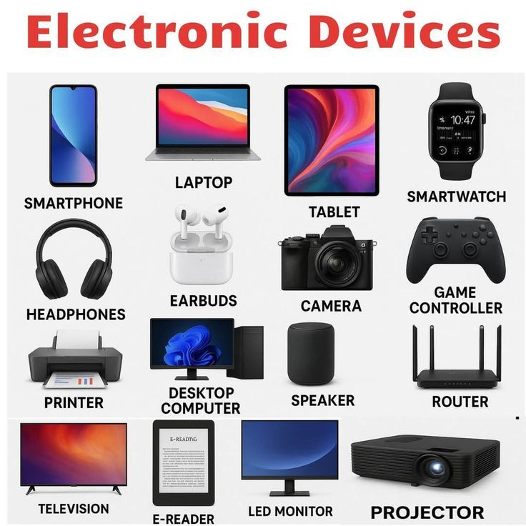
DIGITAL DEVICES IMAGES

